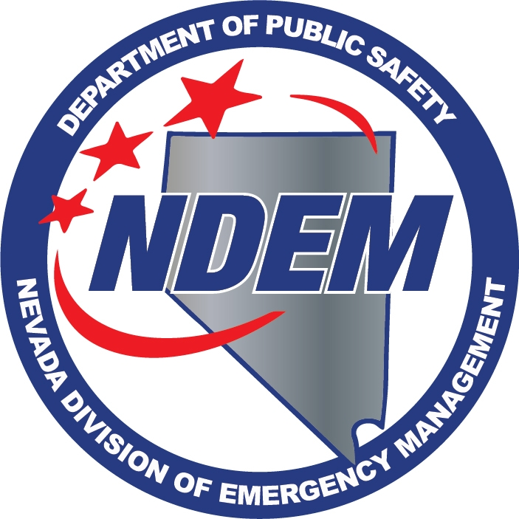 DEPT. OF PUBLIC SAFETY
DIVISION OF EMERGENCY MANAGEMENT
WORKSHOP TO SOLICIT COMMENTS ON REGULATORY ADOPTION
MINUTES

Attendance | Date | March 7, 2016
 | Time | 2:30 PM
 | Location | Legislative Counsel Bureau  Legislative Building, Room 3138  401 S. Carson St.  Carson City, NV 89711
 | Method | Record/Live Stream  Legislative Counsel Bureau  Grant Sawyer State Bldg. Room 4401  555 East Washington Ave.  Las Vegas, NV 89101
 | Recorder | Chris Molnar
 | Present
Caleb Cage | X | Chief/Nevada Division of Emergency Management/Homeland Security Advisor
Samantha Ladich | X | Senior Deputy Attorney General

1. Call to Order – Caleb Cage
Caleb Cage, Chief of the Nevada Division of Emergency Management (NDEM), called the workshop to order at 2:30pm. He introduced Samantha Ladich, Senior Deputy Attorney General.

2. Public Comment

Chief Cage called for public comment, and there was no public comment.

3. Workshop – Chief Cage announced the NDEM is seeking comments on regulatory amendments pertaining to Chapter 414 of the Nevada Administrative Code (NAC) concerning the administration of the Emergency Assistance Account (EAA).

Chief Cage said he would give a brief overview of the changes. He explained the current version of NRS 414.135 creates the EAA and provides for all of the other standards by which it will be administered. He continued to explain that under item 6, of the NRS 414.135, requires the NDEM to adopt regulations as are necessary to administer the EAA. He said the regulations for this account are currently in NRS 414.010. He explained the NACs have been in place for quite some time, and have been effective, but the division believes they are more constraining than the statute requires, so they want to provide some changes thru a public forum with the workshop.

He proceeded to go over the recommended changes by addressing NAC 414.045, which states “any effort to provide a satisfactory remedy to a natural, technological or manmade emergency or disaster.” He said the recommended change would be a satisfactory preparation for or remedy to a natural, technological or manmade emergency or disaster. He explained the change would allow for any preparedness activities, or be prepared in the event of an expected or anticipated emergency or disaster as provided in the definitions of those terms in NRS 414.

Chief Cage continued the discussion about the changes by addressing NRS 414.100, paragraph 3, which states “the Division will use the money in the Emergency Assistance Account to reimburse a state agency that has contributed financial assistance or payments for the deployment of physical resources for costs exceeding their budgetary capabilities.” The division proposed adding “where for any reason the Chief of the Division deems consistent with subsection 3, of NRS 414. 135, and necessary for the protection of life, health, and safety, or property of personnel in the state.”

Chief Cage proceeded to explain the changes to NRS 414.105, subsection 5a, which currently reads “a copy of the declaration of emergency or disaster” should have additional language that states “if applicable or detailed explanation of the emergency or disaster.” He explained that NRS 414 does not require a declaration, but the NAC does and the division would like to broaden that.

Regarding NRS 414.110, subparagraph 1, Chief Cage stated that with the previous change under NRS 414.105, subsection 5a, it would remove the requirement for a declaration of emergency or disaster from the application process. He continued with subsection 4, of the of the same section, which reads “if the applicant is a state agency and a preliminary damage assessment team has not been deployed before application is made, appoint a preliminary damage assessment team to work with officials from the agency to conduct a preliminary damage assessment.” He explained the recommended change is in response to the first change which adds the words “in preparation for.” He said the division wants to have the continued flexibility to use this for anticipated emergencies and disasters. He said with this change, an emergency or disaster would not need to be assessed thru a preliminary damage assessment team.

He concluded the overview, for the record, of the proposed changes to NAC 414 concerning the Emergency Assistance Account.

4. Public Comment
Chief Cage called for public comment. There was no public comment.
5. Adjournment
Chief Cage explained the minutes will be available to the public and members of the community could submit written recommendations following the meeting. Without further participation from the public, Chief Cage adjourned the meeting.

